 

Project Initialization and Planning Phase

|  |  |
| --- | --- |
| Date | 15 April 2024 |
| Team ID | Team-738178 |
| Project Name | Envisioning Success : Predicting University Scores With Machine Learning |
| Maximum Marks | 3 Marks |

**Define Problem Statements (Customer Problem Statement Template):**

The current university scoring systems may lack consistency and accuracy in evaluating critical factors such as quality of education, alumni employment, faculty quality, publications, influence, citations, and patents. This can lead to misleading assessments and hinder prospective students and their families from making well-informed decisions regarding higher education options. Inaccuracies in university scoring also impact universities' reputations and resource allocation, affecting the overall quality and progress of higher education.

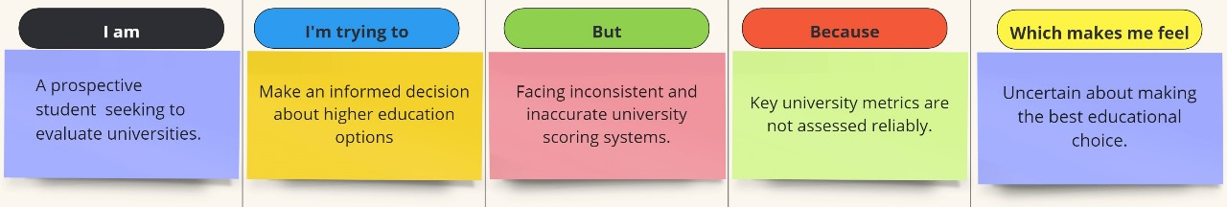

|  |  |  |  |  |  |
| --- | --- | --- | --- | --- | --- |
| **Problem Statement**  **(PS)** | **I am (Student)** | **I’m trying to** | **But** | **Because** | **Which makes me feel** |
| PS-1 | A prospective student seeking to evaluate universities. | Make an informed decision about higher education options. | Facing inconsistent and inaccurate university scoring systems. | Key university metrics are not assessed reliably. | Uncertain about making the best educational choice. |